Lab 5 Documentation – RSA Encryption

# About

GUI Application that encrypts a plaintext message using RSA encryption. The public and private keys can be generated via random prime numbers in a given interval or by setting them manually.

# User Interface

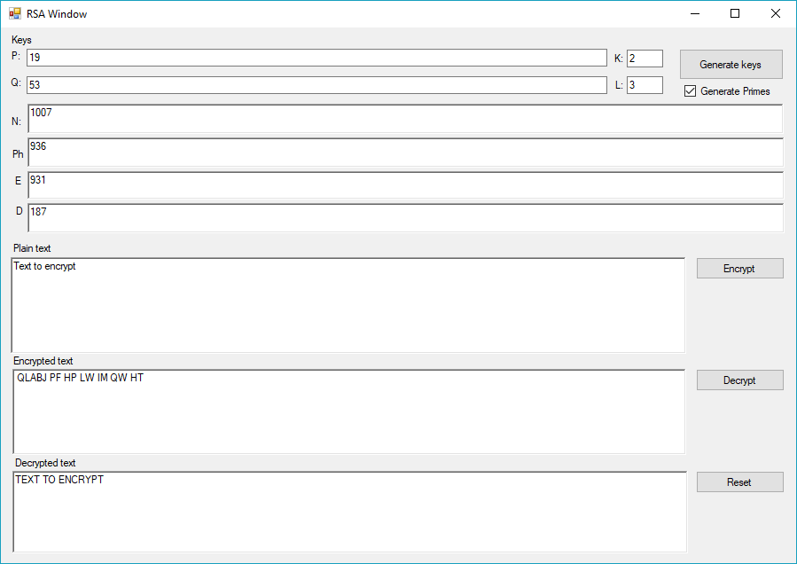

## Usage:

### Key Generation

The P and Q textboxes represent the primary numbers that will be used for generating the public and private keys. These can be generated randomly by pressing generate while the Generate Primes checkbox is checked. The size of the numbers will be determined by the limits set by K and L.   
Optionally if the generate primes checkbox is unchecked you can manually set the prime numbers. In both options the product N and Encryption and Decryption keys will be generated from teh prime numbers.

### Encryption & Decryption

After the keys have been set or generated you can use the Encrypt button to encrypt the plain text, and the ecrypted message will be set in the Encrypted text field. Or if there is an encrypted text set you can use the Decrypt button for obtaining the decrypted text.

Validation against the defined alphabet will be done in on the plaintext before encrypting and on the encrypted text before decrypting.

The reset button clears all of the fields